Rockford Furniture and Designs Inc.

203 North Market Street
Wilmington, De 19801
302-691-3074
www.RockfordFurnitureandDesigns.com

NEW CLIENT QUESTIONNAIRE

Please take a few moments to complete the information requested below.

Brief answers are fine. Use the back of these sheets if you would like to provide more information. Involve your entire household. Have fun telling us about your wants and needs.

We would like to take full advantage of the time we share together and your input is essential. Thank you for your cooperation. All information will be kept confidential.

 | PRIMARY CONTACT INFORMATION: |  |  | Date:
 | Address:
 | City:
 | CONTACT #1: |  |  | CONTACT #2:
 | Name: |  | Name:
 | Day Phone: |  | Day Phone:
 | Evening Phone: |  | Evening Phone:
 | Fax: |  | Fax:
 | Cell: |  | Cell:
 | E-Mail: |  | E-mail:
 | How would you prefer to be contacted? (Check all that apply)
 | Work Phone Home Phone | E -mail |  | Cell Day Eve
 | Part I | HOUSEHOLD INFORMATION

House square footage: _________ Age of house: _____
# Bedrooms: _________ # Baths: __________

How long have you lived in your home and how long do you plan to live in your home?

Do you have plans for the future use of your residence? (Will your rooms need to serve different functions in the future for any household members?)

_____________________________________________________________
_____________________________________________________________
_____________________________________________________________
_____________________________________________________________

Page 1 of 12
Household Members:
Please provide us with the names of the members of your household and what needs they have for space, work, study or special needs. Please include ages of each child.

Name | Work, Study, Space, Special Needs | Birthday
Example: | Will soon need own room or study space, needs better lighting in
Stacy, 10 | bedroom | May 15

Do you anticipate changes for any Household Members: (i.e. College, retirement, etc.) within the next 2-3 years? (Please explain)
_____________________________________________________________

Do you have pets in household? Please list type, age, special needs:
_____________________________________________________________
_____________________________________________________________

Special Considerations – Check any that apply:

Disabled, elderly or young children in the home?

Are occupants daytime sleepers?

LIFESTYLE

ENTERTAINING:
Our entertaining style is:
Formal Informal Combination or both
We entertain:
1-2 times/week 1-2 times/month 1-2 times/year
Average # guests:
1 – 6 7 – 12 More than 12
Average guests ages:
Adults Teenagers Children All ages
Entertaining Type:
Meals Music Games
Watching TV Other _________________________________

Page 2 of 12

MEALS:
What cooking facilities are required? Circle one
Average Above Average Elaborate

Does more than one person cook at a time? |  | Yes / No
Where do you eat your meals?
Dining Table | Kitchen Counter | _____________
Kitchen Table | Family Room | _____________

MAINTENANCE:
How many hours per week will be devoted to cleaning and/or maintenance of your home?
___________________________________________

Do you have professionals clean your home? Yes / No
If yes, how often ? __________________________________________

HOBBIES:
Do the household members share common time around the home together? Yes / No

If yes, is an area needed to accommodate you? Yes / No Explain:
____________________________________________________________

Do you have any collections? Yes / No If yes, please list-
________________________________________________________
Are any collections on display? Yes / No
If you circled yes, would you like to display your collection? Where?
_____________________________________________________________
Hobbies:
Reading | T.V. / Home Theater | Crafts/ Sewing
Entertaining | Music | Sports
Cooking | ____________________
What are your technical needs?
Computers | Surround Sound | Other__________
Wireless DSL/Satellite Home Theater |  | ________________

Are you looking to create a children’s play area? Yes / No

Page 3 of 12

HOME OFFICE:

Does any household member work from home? Yes / No
If yes, are there any special needs (i.e., lighting, soundproofing, computers, etc.)?
_____________________________________________________________
_____________________________________________________________
_____________________________________________________________

Is there a designated area for working in your home ? Yes / No LIGHTING

Is additional lighting needed? If yes, locations:

Bathroom Office Living Room Family Room Bedrooms Kitchen/nook Other____________

STORAGE

Multipurpose Furniture
Hidden Storage (for clutter issues) Closet Storage/ Organizers

VACATION TIME:

We stay at home for our rest/relaxation: All the time Some of the time Rarely

We travel for our vacations:
All the time Some of the time Rarely

Part II PROJECT INFORMATION

Person(s) responsible for project decisions: _________________________

What is the budget for your project?

□ $5,000 – 10,000 □ $10,000 - $30,000

□ $40,000 - $90,000 □ $100,000 – $200,000

The project is to be done: All at one time________In stages________

Will occupants be home during project/construction for access?

If not, will you authorize neighbors or designee to provide access?

Page 4 of 12

Priorities:
_____________________________________________________________
_____________________________________________________________
_____________________________________________________________.

Please “X” the rooms to be included in the project. If the project will be done in stages, please indicate the order of the work by writing a number in the box to show the order (1= first, 2= second, etc.)

Entry Hall / | Formal | Formal | Family /
Foyer | Living Room | Dining Room | Great Room
Kitchen | Nook | Office/Study | Laundry Area
Master | Master | Hall | Guest
Bedroom | Bathroom | Bathroom | Bathroom
Bedroom #2 | Bedroom #3 | Bedroom #4 | Other _______
Home Theater/ | Outdoor | Outdoor Living | Other _______
Media Room | Kitchen | Area

What kind of enhancements are you considering? (Please check all that apply)

Furniture | Flooring | Upholstery
Remodel Kitchen | Window | Remodel Bathroom
 | Treatments
Window replacements | Artwork, | Appliances
or changes | mirrors, etc.
Interior paint | Accents | Plumbing fixtures
Exterior paint | Space planning | Room addition
Wallpaper | Murals | Lighting
Wall finishes | Color scheme/ | _________________
 | Paint

What is your favorite room in the house? ______________________
Why? ______________________________________________________

What don’t you like about your current home? ________________
Why? _______________________________________________________

Page 5 of 12

What part of your house do you use the most? _______________

What part of your house do you use the least? ________________

Are there any pieces of furniture, window, wall or floor coverings that must stay, and be worked into the new plan?
Please explain:
_____________________________________________________________
_____________________________________________________________
_____________________________________________________________

Are there any items that MUST GO? Please explain:
_____________________________________________________________
_____________________________________________________________

How involved do you wish to be in this project: (Please check)
Very involved (Call you with details and updates daily or weekly)

Involved – Rockford Furniture and Designs Inc. to act as project manager (Keep you updated with install dates, deliveries, work schedule etc.)

Minimally involved – don’t call until everything is ready to install

Other: _______________________________________________

What is your “ideal” timeline for your project?

Within 3 months

Other _______________________________________________

PART III DESIGN PREFERENCES

Design Goals

Prioritize the following personal design goals for your home from 1-3, with 1 being your most important quality.

_____I am interested in achieving a more stylish/beautiful appearance for my home
_____I want my home to function more effectively for my household.
_____I want my home to better reflect our personal tastes.
Other ___________________________________________________

Would you like to include “green products” when possible?
Yes No what do you mean?

Page 6 of 12
What “feeling” are you seeking to achieve?

Casual Formal Spacious Clean lines Warm/ cozy
Light/airy Elegant Sophisticated “Lived in” Welcoming
Romantic Contemporary

What style are you seeking to achieve? [See Style Photos on pages to follow]

Tuscan | Mediterranean | French Country | Mission style
Beach Cottage | Country Cottage | Asian | Southwestern
Old World | Art Deco | Early American | Industrial

Do you and your partner’s style preferences agree? Circle Yes / No

Comments:
_____________________________________________________________
_____________________________________________________________

The following questions are designed to provide us with a general description of your likes and dislikes regarding your personal style:

Select from the following to describe your preference in fabric: (Check all that apply)

Paisley | Stripe | Plaid | Toile | Silk
Sheer | Leather | Bold pattern | Suede | Velvet
Subtle pattern | Satin | Cotton | _______ | ________

Preferences of Color: (Check all that apply)

Whites | Oranges | Blues | Pastels
Blacks | Reds | Jewel Tones | Grays
Burgundies | Navy Blue | Neutrals | Beiges
Pinks | Powder Blue | Earth tones | Tans
Aquas | Warm Colors | Pale yellows | Eggplant
Mint Greens | Cool Colors | Yellows | Lavenders
Olive Greens | Subtle | Peach | Purples
Forest Greens | Bright | Bold | Greens
Teals | ____________ | ____________ | ___________

Colors you dislike? _____________________________________
Do you have a color theme in mind? | Yes | No
Please Describe:
Page 7 of 12

Are there types of flooring you prefer? (Please check all that apply)

Hardwood |  |  |  | Carpet |  | Laminate
Natural Stone |  |  |  | Concrete |  | Tile
Combination |  |  |  | Bamboo |  | Cork
Are there types of window treatment you prefer?
(Please check all that apply)
Custom Draperies |  |  |  | Blinds |  | Sheers
Shutters |  |  |  | Room Darkening |  | Curtains
All Fabrics |  |  |  | Natural Materials |  | Metal
Shades |  |  |  | Other |  | Combination
 |  |  |  | _________________ |  | _________________
Do you need sun control or privacy with your window treatments?
Yes | No

Additional information regarding preferences:

Have you ever hired an interior designer before? Circle Yes / No
If yes, when did this take place, and were you pleased with the experience and the results:
________________________________________________________________________
________________________________________________________________________
________________________________________________________________________

The following pages include style photos you can reference when answering the second question on page 7.

Thank you for your input. We look

forward to serving you with your design needs. You may fax or mail us pages 1-8

203 North Market Street
Wilmington, DE 19801

Fax: (302) 658-5956

Page 8 of 12

TUSCAN:
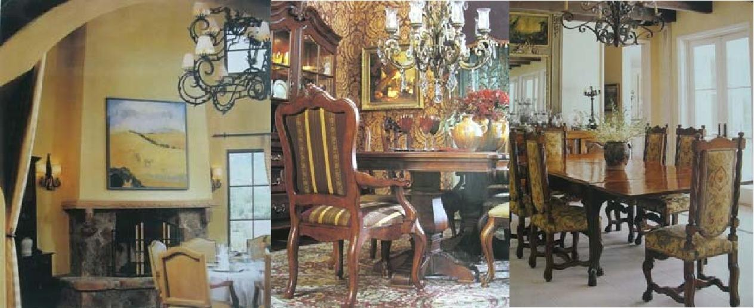

BEACH COTTAGE:
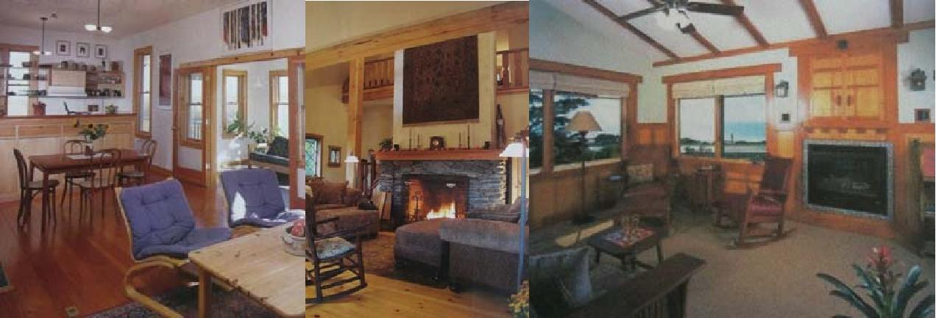

OLD WORLD:
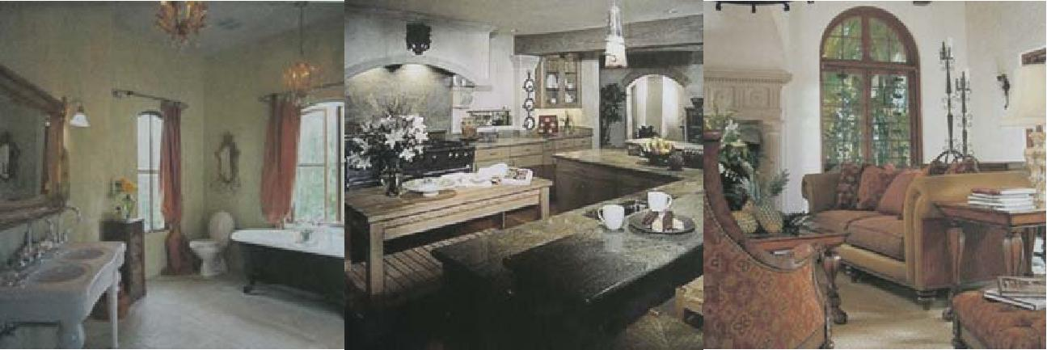

Page 9 of 12

MEDITERRANEAN:
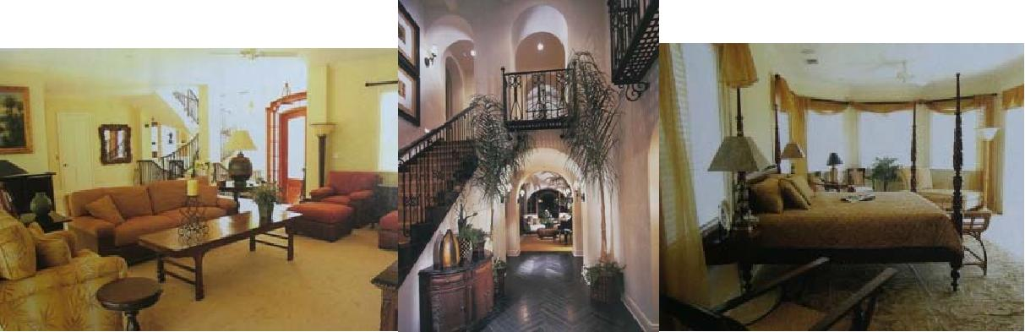

COUNTRY COTTAGE:
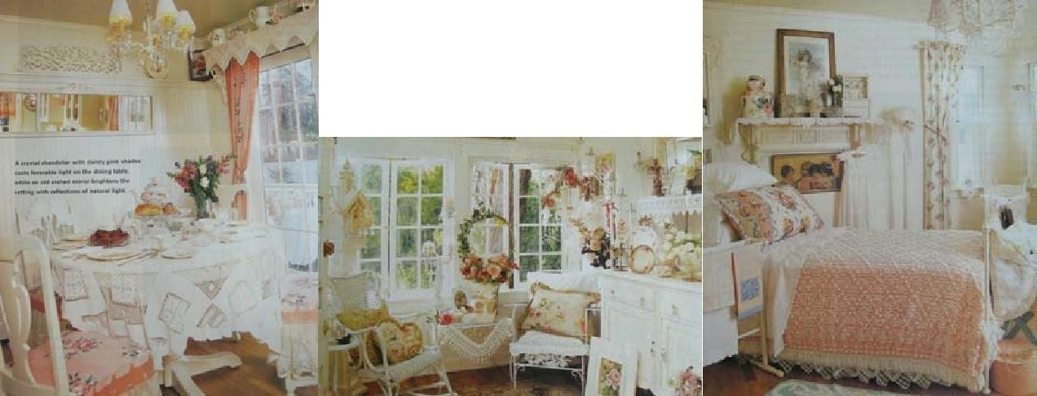

ART DECO:
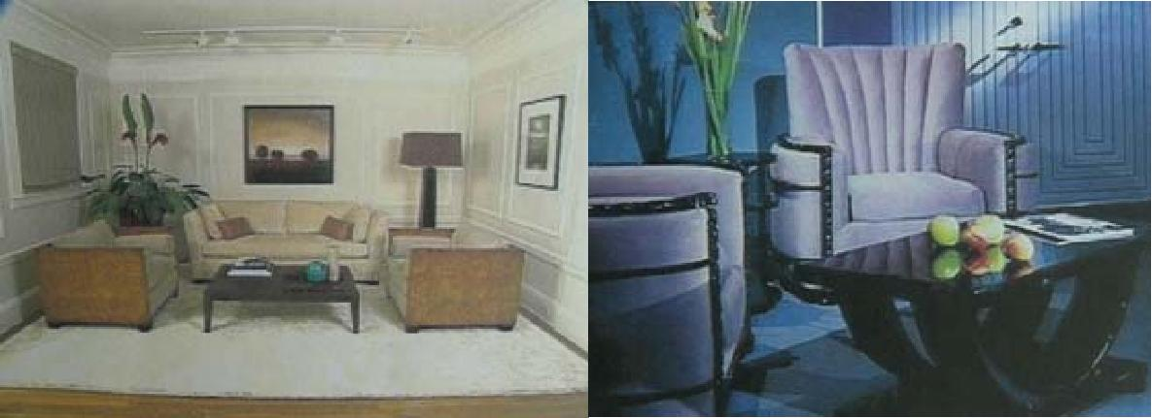

Page 10 of 12

FRENCH COUNTRY:
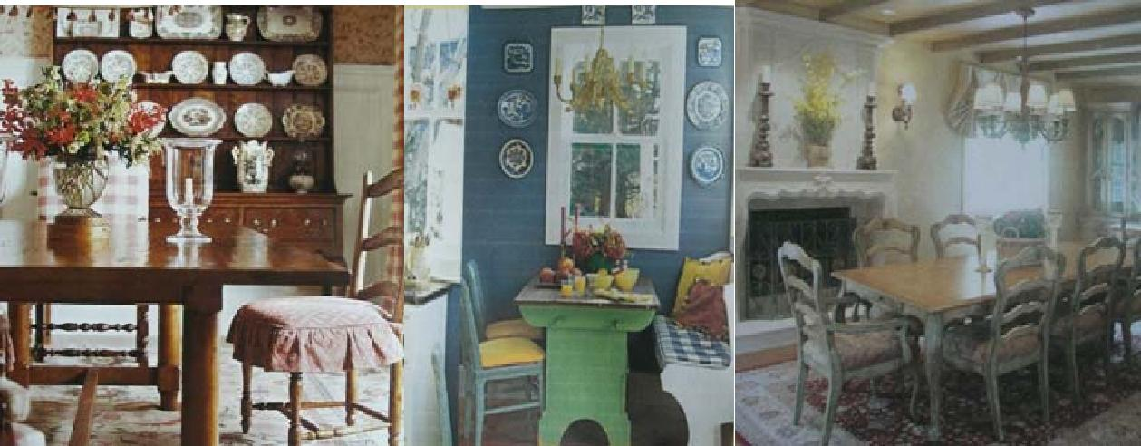

ASIAN:
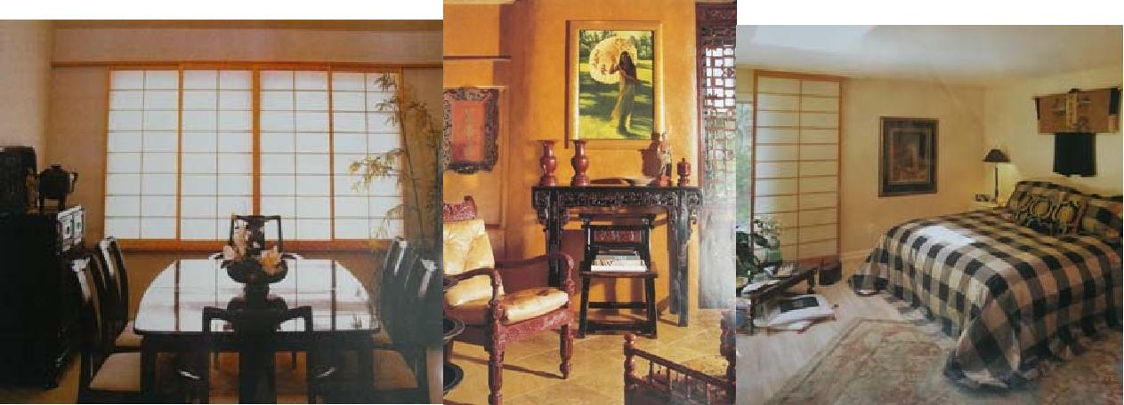

EARLY AMERICAN:
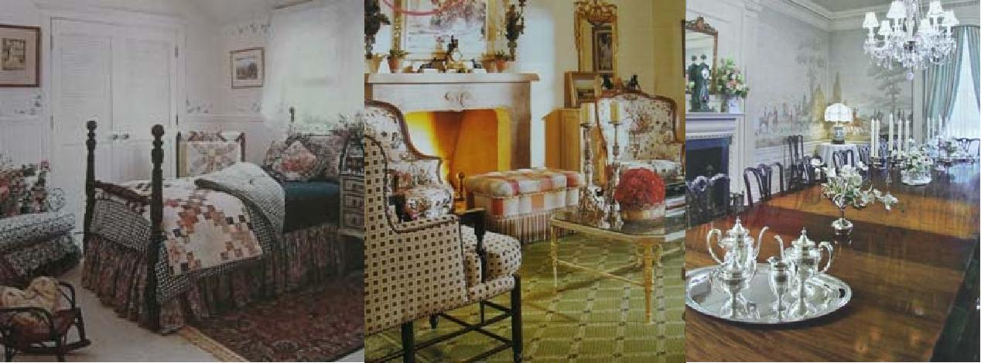

Page 11 of 12

MISSION:
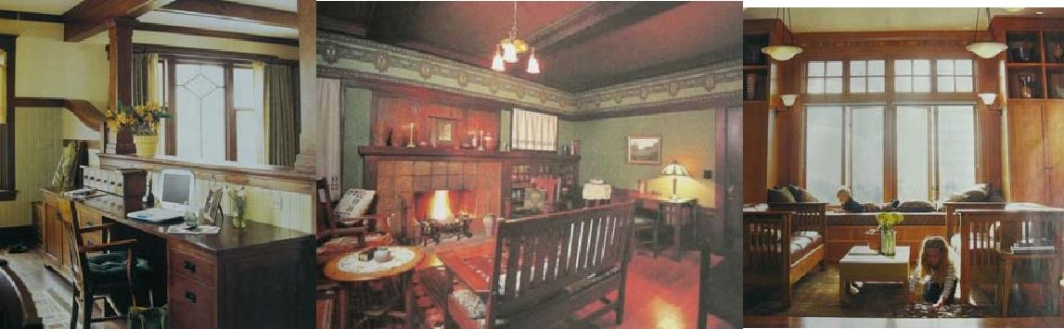

SOUTHWESTERN:
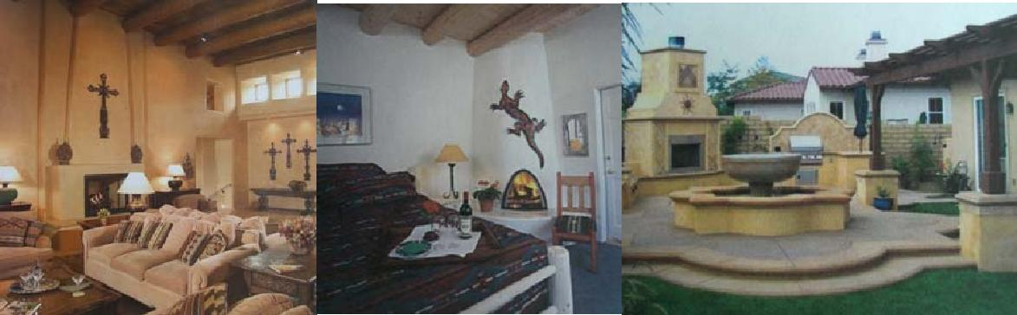

INDUSTRIAL:
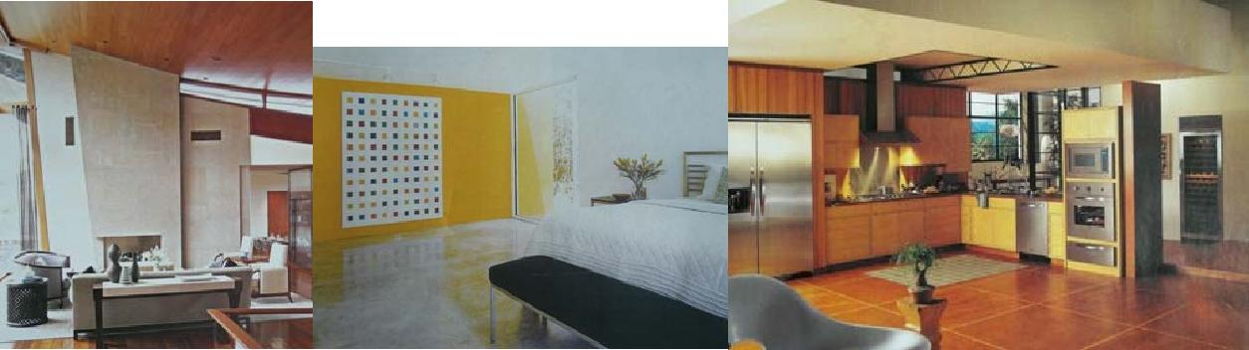

Page 12 of 12

